

**UNIT 7. WINDOWS ADMINISTRATION -PART 1-**

**COMPUTER SYSTEMS**

**CFGS DAW**

Autores: Sergi García / Alfredo Oltra

Revisado: Vicent Bosch [vicent.bosch@ceedcv.es](mailto:vicent.bosch@ceedcv.es)

2020/2021

Versión:201212.1535

# Licencia

 **Reconocimiento – NoComercial – CompartirIgual (by-nc-sa)**: No se permite un uso comercial de la obra original ni de las posibles obras

derivadas, la distribución de las cuales se debe hacer con una licencia igual a la que regula la obra original.

# Nomenclatura

A lo largo de este tema se utilizarán distintos símbolos para distinguir elementos importantes dentro del contenido. Estos símbolos son:

◻ Importante

 Atención

 Interesante

**INDEX**

1. Introduction 3
2. Windows 10 new features 3
3. Windows 10 requirements 3
4. File systems in Windows 10: FAT and NTFS 4
   1. File system structure in Windows 10 4
   2. Main file/folders operations in Windows 10 4
   3. Main Windows file extensions 5
   4. Files and folders attributes 6
5. Windows 10 applications 7
   1. Programs and features 7
   2. Windows 10 store 7
   3. File extensions associations and default programs 7
   4. Run programs in Windows 10 7
6. Managing User accounts 9
7. Basic use of console 10
   1. Main commands 10
   2. Redirections 12
   3. Shortcuts 13
   4. Wildcards 13
8. Help (command) 13
9. Additional material 15
10. Bibliography 15

# INTRODUCTION

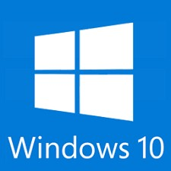In this unit we are going to study how to administrate a Windows client operating system.

Windows Server 200X are server operating systems. The most common Windows client operative systems are Windows XP, Windows Vista, Windows 7, Windows 8 and Windows 10. Their functionality and use are very similar.

In this unit we are going to study Windows 10, but what you learn could be applied to other Windows operating systems.

 In this unit basic knowledge about using operative systems is required.

# WINDOWS 10 NEW FEATURES

Windows 10 is very similar a previous Windows versions, but it includes several news that make it the best Windows client operative system:

* + New version of Internet Explorer: Microsoft has improved Internet Explorer and now is called Microsoft Edge. Nowadays, it can compete against Mozilla Firefox and Google Chrome.
  + Windows start button has returned. It has a lot of improvements, like integrating local and Internet search in the start button.
  + Windows 10 can manage several virtual desktops.
  + Voice (and text) assistant Cortana is integrated with operative system.
  + Windows 10 can adapt himself to different devices (depending on if they have touch screen or not).

# WINDOWS 10 REQUIREMENTS

Windows 10 requirements are available in Microsoft's [website](https://www.microsoft.com/es-es/windows/windows-10-specifications). These requirements are:

* + Processor: at least 1 GHz.
  + RAM memory: 2GB for 32 and 64 bits versions.
  + Disk space: 16GB for a 32 bits version and 20 GB for a 64 bits version.
  + Graphic card: graphic card with DirectX 9 support.
  + Screen: screen with at least 800x600 resolution support.

# FILE SYSTEMS IN WINDOWS 10: FAT AND NTFS

Windows supports the following file systems:

* + **FAT32** (File Allocation Table): used in first Windows versions. It is a light file system (It has no permissions and other features). It is the most compatible of all Windows file systems (supported by a lot of devices and operating systems). Nowadays useful for simple devices like MP3 players or mobile phone data.
  + **exFAT** (Extended File Allocation Table): new file system designed for removable units like USB pendrives. It extends FAT to use larger partitions and create larger files.
  + **NTFS** (New Technology File System): it is the most common used. It has features like permissions, log of changes (to help to restore information if disk fails) and file system cipher. It heavier than FAT systems and it is not compatible with all devices and operating systems.

Windows 10 should be installed using NTFS file system.

* 1. File system structure in Windows 10

The main features of Windows 10 file system structure are:

* + - Windows 10 has a hierarchic tree structure (there is a main root and directories depend of it).
    - Windows 10 has storage units. Usually each unit correspond to a partition or a external device. There area named with letter from A to Z.
    - Windows operative systems usually have their files in “C:\Windows” and specially in “C:\ Windows\system32”
    - User documents usually are stored en “C:\Users”.
    - Installed programs are usually in “C:\Program Files” or “C:\Program Files (x86)” (this directory is for 32 bits programs that run in a 64 bits operating system).
  1. Main file/folders operations in Windows 10

We are going to show the most common file/folders operations in Windows 10:

* + - Select more than 1 item:
      * If they are together, you can click in the first item, hold *shift* key and click in the last item.
      * If they are separated, you can click in the first item, hold *control* key and click in the items that you want to select.
    - Copy, cut and paste selected items:
      * Right click and select the selected option: copy, cut or paste.
      * Using the keyboard:
        + Copy: *Ctrl + c*
        + Cut: *Ctrl + x*
        + Paste: *Ctrl + v*
      * Select all items
        + In the Explorer Window: *Start*, and then *Select all*.
        + Keyboard: *Ctrl + e*
      * Create folders
        + Right click in a blank space, then *New* and then *Folder*.
      * Rename items
        + Right click on the item, and then *Rename*.
        + Keyboard: *F2* key.

If you have problems with Copy/Cut/Paste, [this](https://youtu.be/baWop2j7S7g) video tutorial could help you

* 1. Main Windows file extensions The main Windows file extensions are:
     + exe: executable files.
     + msi: Microsoft Installer (To install programs).
     + bat: Batch files (Scripting language with Windows commands).
     + ps1: Batch files (Scripting language with Windows commands).

◻ By default, Windows 10 hide system files (files that belong to operating system) and also hide extension of files. For a normal user it is OK, but for an administrator is recommended to show extension files and show system files.

In this [video](https://www.youtube.com/watch?v=2p_EUSDyrvo) you can watch how to show file extensions and show system files.

* 1. Files and folders attributes

Windows files and folders have attributes that can be checked or not (not confuse attributes with permissions). The attributes are:

* + - Common attributes
      * **Hidden**: this item is hidden, unless you have deactivated hidden files.
      * **Read only**: it is used to avoid modify or delete an item but it is only a piece of advice, if you want, you can modify or delete that file.

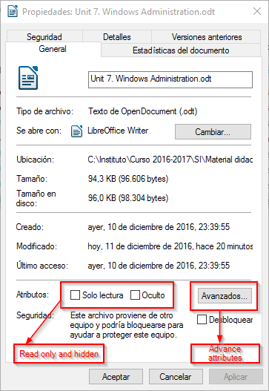

* + - Advanced attributes
      * **Indexed**: it indicates that item is stored in an index to do quicker searches. You can select if index the file or the file and its contents.
      * **Compress**: the file is automatically compressed in the file system.
      * 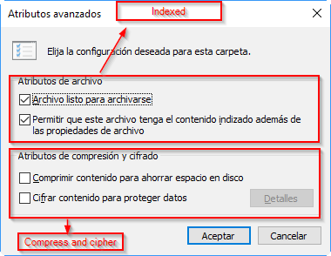**Cipher**: the file is automatically ciphered. Cipher and Compress are incompatible.

# WINDOWS 10 APPLICATIONS

* 1. Programs and features

Programs and features is an standard menu to install or uninstall applications. In this Video you can watch several ways to go to “Programs and features”

[http://www.isunshare.com/windows-10/5-ways-to-open-programs-and-features-in-windows-](http://www.isunshare.com/windows-10/5-ways-to-open-programs-and-features-in-windows-10.html) [10.html](http://www.isunshare.com/windows-10/5-ways-to-open-programs-and-features-in-windows-10.html)

Also in this video you can watch how to use it <https://www.youtube.com/watch?v=LaOkoG2VOfs>

* 1. Windows 10 store

Windows 10 has an application store (Similar to Google Play for Android devices). It lets you to install/buy applications and easily uninstall them.

In [this](https://www.youtube.com/watch?v=P_jPGiysvOY) video you can watch how to use Windows Store

* 1. File extensions associations and default programs

Windows 10 let you to select default applications for several actions (I.E. Mozilla Firefox for Internet Navigation) and also associate a file extension to an application (to open determinate kind of files with and application I.E. “.odt” files with LibreOffice Writer).

In [this](https://www.youtube.com/watch?v=lbZ1ftAZ8UU) video you can watch how to change default applications and default file extension associations in Windows 10.

* 1. Run programs in Windows 10

Usually you can run a program doing double-click it. It is the most common way to run a program using Windows graphic interface.

Also, there are ways to run commands like:

* + - 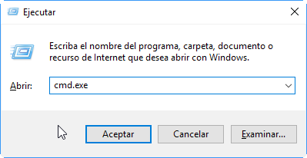Run window: that window let you to run one command. You can access it pressing *Windows key + r*.
    - Console: Windows has a text console. It is very useful for advance commands. Administrators have to know how to use text console. You can access using the following ways:
      * Use *Windows key + r* and run CMD.exe.
      * 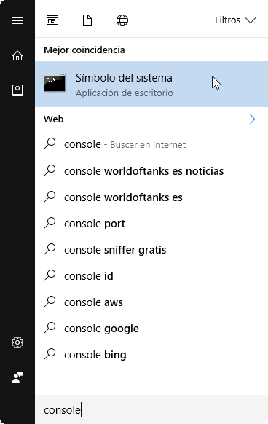Searching “Console” in Windows start button. You should find “Command prompt” item.
      * 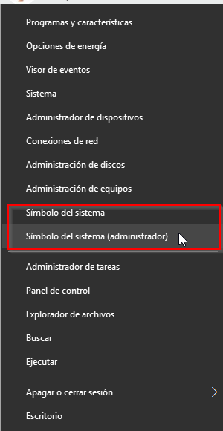Doing right click in *Start button* and selecting it.

 When you run Windows console, you can run it in *Normal mode*

and in *Administrator mode*.

Several operations only can be done in *Administrator mode*. To select between it, you should right click in *Command prompt* and select *Run as administrator*.

# MANAGING USER ACCOUNTS

Windows 10 let you to manage accounts. In this Windows version, you can link your local account with Microsoft accounts (Accounts for Hotmail, Skype, One drive, Xbox live,...)

Mainly there are three types of accounts:

* + **Guest account**: is a special account to let people without user to use the computer. By default, it is disabled. You have to enable it if your system needs it (for example, a computer in public library to find books).
  + **Standard accounts**: they are limited accounts, and they only can do basic actions (execute programs without administrator rights, modify their own files,…).
  + **Administrator accounts:** this accounts have administrator rights. They can do several actions like install programs, install hardware, create/delete/modify user accounts, ….

◻ The recommended configuration is to use only administrator accounts to do administration tasks.

For general purposes, you should use Standard accounts, even if you are an expert user (if you do a mistake or if you get a virus, in a Standard account the system could be less damaged).

In [this](https://www.youtube.com/watch?v=He6EzgR4ut4) video you can watch how to create/add/delete accounts in a Windows 10 system

# BASIC USE OF CONSOLE

Usually we interact with operating system using GUI (Graphical User Interface). But a lot of times, is very useful to use the Windows command line console (and several operations can only be done using console). For an expert user is very important to know how to use command line console.

 The main advantage of use the console is concretion. Order *dir c:* tell to show all files and directories of c:\. Concrete commands are very useful to automatize processes.

To say the same in a GUI would be something like “Open explorer, click in position 100,100, then view the files,..” and it is more ambiguous to understand for a machine.

There are a lot of commands, but the most important of them is “help” command because it is the command that tell you how to use other commands.

* 1. Main commands

|  |  |  |
| --- | --- | --- |
| **Command** | **What it does** | **Example** |
| **Commands to manage the interface** | | |
| help | Muestra la ayuda de un comando | *help dir* |
| cls | Clear screen | *cls* |
| echo | Show a literal text in screen. | *echo “Hello World”* |
| pause | Pause execution until a key is pressed | *pause* |
| exit | Closes the console | *exit* |

|  |  |  |
| --- | --- | --- |
| **Commands for system configuration** | | |
| date | To set / view system date | date |
| time | To set / view system time | Time |
| set | • Para establecer una variable de entorno. Hay variables creadas por el sistema y variables creadas por los usuarios.  • El parámetro / P pregunta el contenido de la variable desde el teclado  echo para mostrar el valor de una variable (la variable debe estar entre%). | set x=”Hola”  *x obtains “Hola” value*  set /P myNumber=”Write a number”  *“Write a number” is shown and the string write by the user is the value of my number*  echo The username is %username”  *Uses the system environment varible “username” and show its value* |
| shutdown | Shutdown the computer | shutdown |
| systeminfo | Shows information about the computer | systeminfo |

|  |  |  |
| --- | --- | --- |
| **Commands for disk units** | | |
| format | Format a partition | *format c: /Q* |
| chkdsk | Check and repair a disk/partition | *chkdsk c: /F /R* |
| label | Changes the label of the current volume | *label* |
| vol | Shows name of the current volume | *vol* |

|  |  |  |
| --- | --- | --- |
| **Commands for file management** | | |
| type | Shows the contents of a file | *type readme.txt* |
| rename | Changes the name of a file/folder | *rename readme.txt LEEME.txt* |
| del | Deletes a file or a folder | *del myFile* |
| copy | Copies a file or a folder | *copy myFile c:\newFile.txt* |
| move | Move a file or a folder | *move myFolder c:\myNewFolder* |
| attrib | Let to modify attributes of a filer or a folder | *attrib -h myHiddenFile.txt* |
| assoc | Show extensions and the kind of file they are | *assoc assoc .txt* |
| fc | Compares two files and show the differences (if any) | *fc file1.txt file2.txt* |
| find | Try to find strings in a file | *find Jordan BestBasketPlayers.txt* |
| sort | Sorts the contents of a file | *sort myFile.txt* |

* 1. Redirections

Usually, when we use a program from console, the main input comes from keyboard and the main output is the screen.

There are commands to re-direct input from a file or output to a file.

|  |  |  |
| --- | --- | --- |
| **Redirection** | **What it does** | **Example** |
| > (Output redirection) command > file | Creates a new file with the output. If the file existed previously, it previous content is deleted. | *echo Hello > hello.txt* |
| > (Output redirection) command >> file | Creates a new file with the output. If the file existed previously, new content is added at the end of previous content. | *echo Bye >> hello.txt* |
| < (Input redirection) | Uses the content of a file as it was typed using keyboard | *sort < fileToSort.txt* |
| | (input and output redirection) | Uses the output of a command | *type fichero.txt | sort* |

|  |  |  |
| --- | --- | --- |
|  | as input of other command |  |

* 1. Shortcuts

When you are typing commands in console, you can use tab key to auto-complete the command or the absolute/relative route that you are writing.

Also, if you want to recover a previous introduced command, you can use keys “up” and “down” to move between typed commands.

* 1. Wildcards

When you use routes in commands, a lot of time you have to use wildcards. Windows console has two types of wildcards:

* + - **Asterisk *:** * can be replaced by 0 to many characters. For example, if you want to list all the files and folders that start by *Example* you can type *dir Example\**.
    - **Question mark ?:** ? can be replaced by zero or one character. For example, if you type *dir Example?.txt* you would find *Example1.txt*, *Example.txt*, *Example2.txt*,... but not *Example 3.txt*.

# HELP (COMMAND)

Previously we have said that the most important command is *help*, because it displays information of how to use other commands. It is very useful to understand the function of each command.

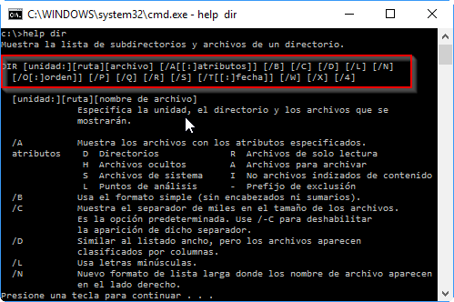

In this image we can view a first a string telling what parameters has *dir* command and later information about the parameters.

We want to know how to interpret the first part of the image:

|  |  |
| --- | --- |
| **Format** | **Explanation** |
| lowercase or *cursive* | Information that must be provided by the user. Example “ruta” where you have to write the route you want. |
| UPPERCASE or **bold** | Information that is always written how it is show. Example DIR. |
| Three points (…) | A parameter that could repeat itself several times. |
| Brackets [] | Optional parameters.  For example, if you don’t provide [ruta] it takes your current route as default parameter. |
| Braces {} with option separated by |.  If instead of braces, there are brackets *[]* with options, it means that this selection is optional. | You have to choose one of the possibilities.  For example {YES | NO} you only can use parameter YES or parameter NO, but you can not use both at the same time. |

# ADDITIONAL MATERIAL

[1] Windows Training

<https://www.microsoft.com/en-us/learning/windows-training.aspx>

# BIBLIOGRAPHY

1. Windows 10

<https://en.wikipedia.org/wiki/Windows_10>

1. Microsoft support<https://support.microsoft.com/>